Title

Author One^{1*}, Author Two² and Author Three¹
¹ Department, Institution; ² Department, Institution

Abstract style in Times New Roman 12 point, indented 1.0cm to the left and right of the margins. Abstracts should be no more than 250 words. This is an example of the abstract style. This is an example of the abstract style. This is an example of the abstract style. This is an example of the abstract style.

Keywords: Keyword or phrase, keyword or phrase, keyword or phrase (maximum of 3)

Sub-Heading

Body text style in Times New Roman 12 point. This is an example of the body text. This is an example of the body text style. This is an example of the body text style. This is an example of the body text. This is an example of the body text style. This is an example of the body text style.

This is an example of the body text style. This is an example of the body text:
- Example bullet list
- Example bullet list
- Example bullet list

This is an example of the body text style. This is an example of the body text:
  - Example ordered list
  - Example ordered list
  - Example ordered list

Table 1: Example caption/title for table

Table heading 1 | Table heading 2 | Table heading 3 | Table heading 4

Quotation style in Times New Roman 12 point, indented 1.0cm to the left and right of the margins. This is an example of quotation style. This is an example of quotation style. (Reference, year)

Body text style in Times New Roman 12 point. This is an example of “a very short quote.” This is an example of the body text style. This is an example of the body text style. This is an example of the body text. This is an example of the body text style. This is an example of the body text style.

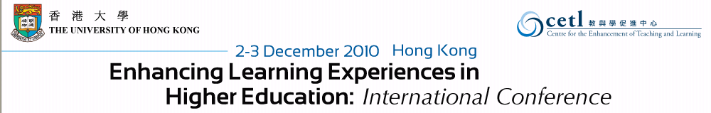
Figure 1: Example caption/title for figure

Acknowledgements

Acknowledgements appear in body text style in Times New Roman 12 point. This is an example of acknowledgements in body text style. This is an example of acknowledgements in body text style. This is an example of acknowledgements in body text style.

References

Bates, A.W. (2000). Managing technological change: Strategies for college and university leaders. San Francisco, CA: Jossey-Bass.
Berge, Z.L., Collins, M., & Dougherty, K. (2000). Design guidelines for web-based coursed. In B. Abbey (Ed.), Instructional and cognitive impacts of web-based education (pp. 32-40). Hershey, PA: Idea Group Publishing.
Chandler, T. (2001). Outback and in again: A new graduate’s experience of rural and remote nursing. Sixth National Rural Health Conference. Retrieved from http://www.abc.net.au/health/papers/paper11.htm.
Edward, C. (1999). Models for web-based instruction: A discussion of recurring themes. In K.E. Sparks & M. Simonson (Eds.), Proceedings of the 21st National Convention of the Association for Educational Communications and Technology (pp. 319-321). Houston, TX: AECT.
Reeves, T.C., & Laffey, J.M. (1999). Design, assessment, and evaluation of a problem-based learning environment in undergraduate engineering. Higher Education Research and Development Journal, 18(2), 219-232. doi: 10.1080/0729436990180205

Copyright © 2010 <Insert names of authors here>. The authors assign to CETL, HKU the right to publish this document in full in the conference proceedings. Any other usage is prohibited without the express permission of the authors.

